Prof. Dan Vounpheng
EASYBANK
MANAGEMENT
SYSTEM
class of 2025
S1E3Y3

Table of content

- Introduction

- Project Objective

- Project Description

- UML Class

- Conclusion

EasyBank Account System

- Introduction

​​​​​​​​​​​​​​ Project នេះបានបង្ហាញថា software technology អាចជួយឲ្យការងារ Banking operations កាន់តែមានប្រសិទ្ធភាពប្រសើរ និងជួយបង្កើន customer service បានល្អជាងមុន រួមជាមួយភាពងាយស្រួលដល់អតិថិជន។

- Project objective
To develop a secure banking system ដែលអនុញ្ញាតឲ្យអ្នកប្រើប្រាស់អាច register, log in, និងធ្វើប្រតិបត្តិការ basic transactions ដូចជា deposit, withdrawal, និង balance inquiry, ដើម្បីធានា data accuracy និងការប្រើប្រាស់ដែលមានលក្ខណៈជា user-friendly​ ផងដែរ។
- Project Description
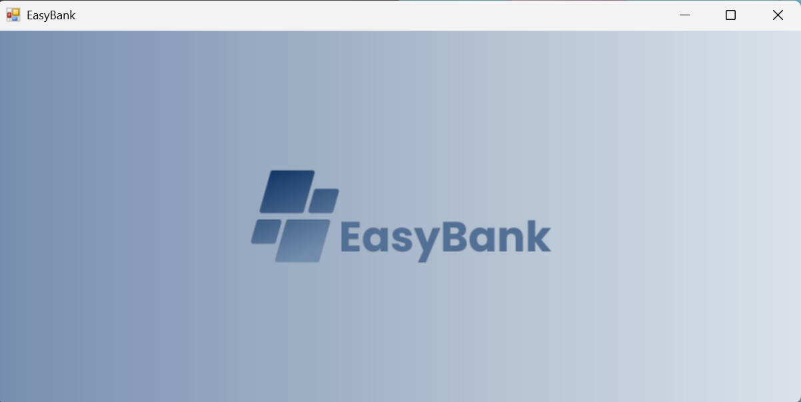
- 1st form : Splash Screen
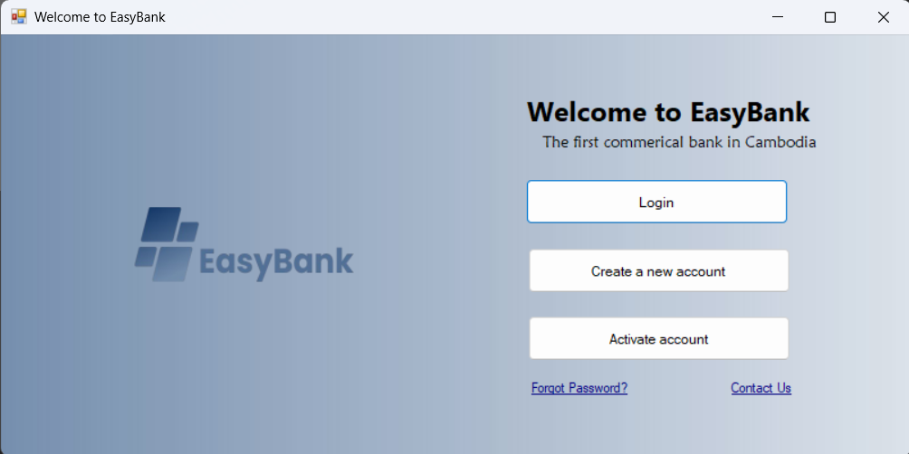
- 2nd Form : frmWelcome

After delay the frmSplashScreen for 3s, the frmWelcome pop up.
- 3rd Form : frmLogin
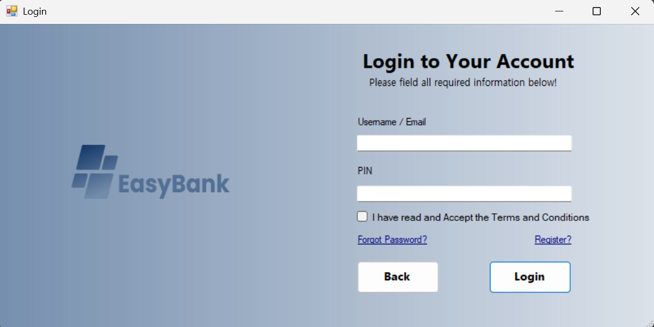
After user click on btnLogin the it will pop up the form login

- In form login :
- If user didn’t input require fields the system show message box as below:
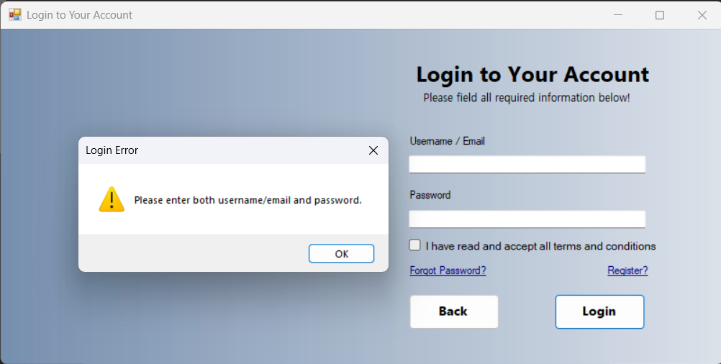

- If user input data that doesn’t exist in the system :

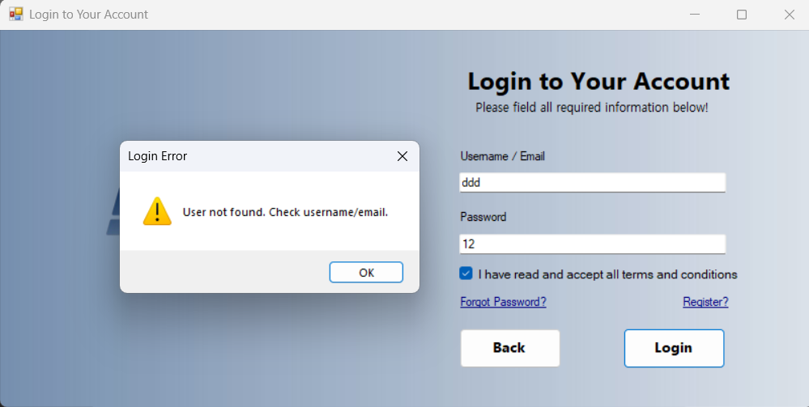

- If they have input wrong password :

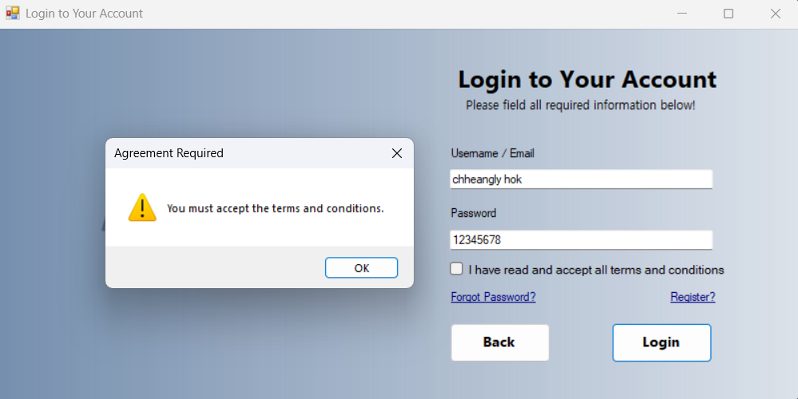
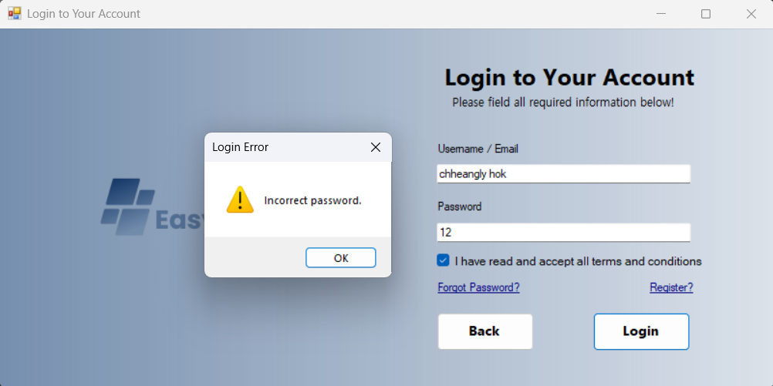
- If they don’t check the Term and Condition :

- If they have already register
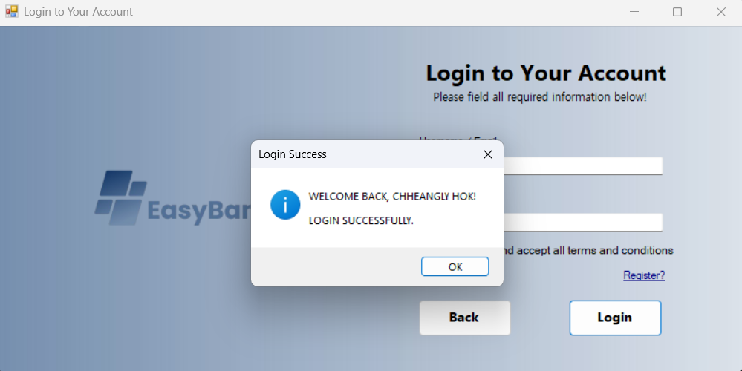

- The system will directly open the frmDashboard as below:
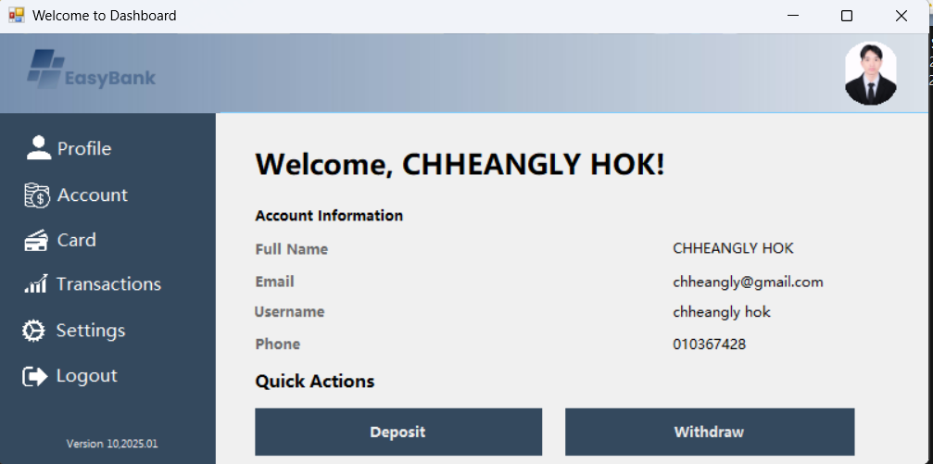

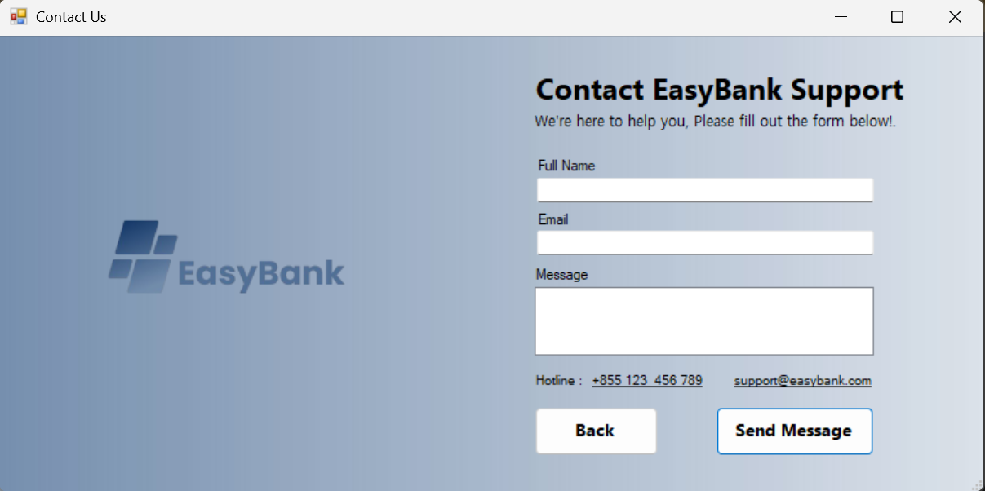
- 4th Form: frmContactUs

User can raise any concern related to our service by require some information.
- If they missed the require field:
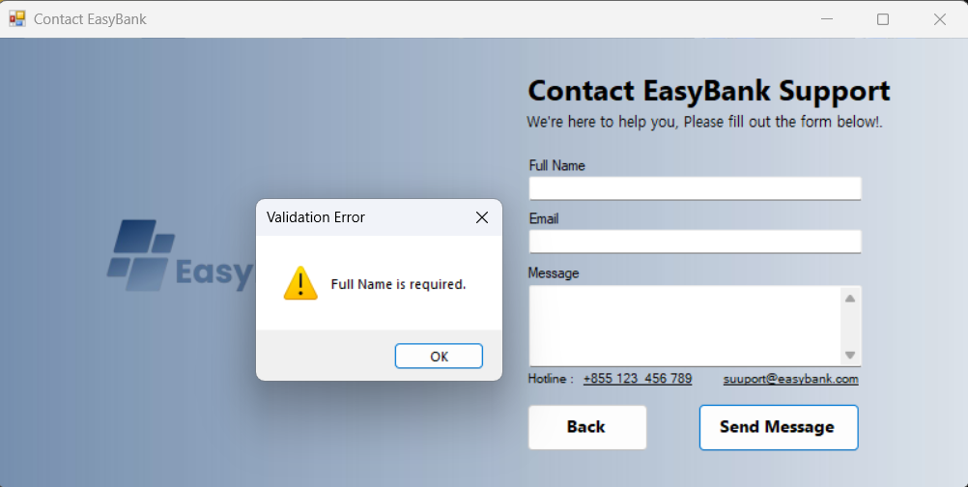

- We have validated on data that input from user:
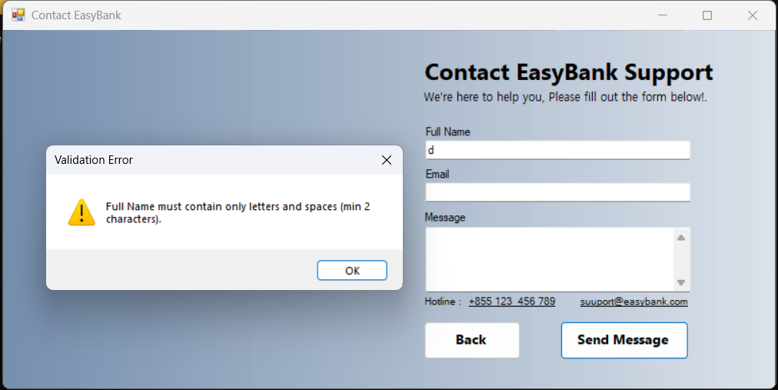

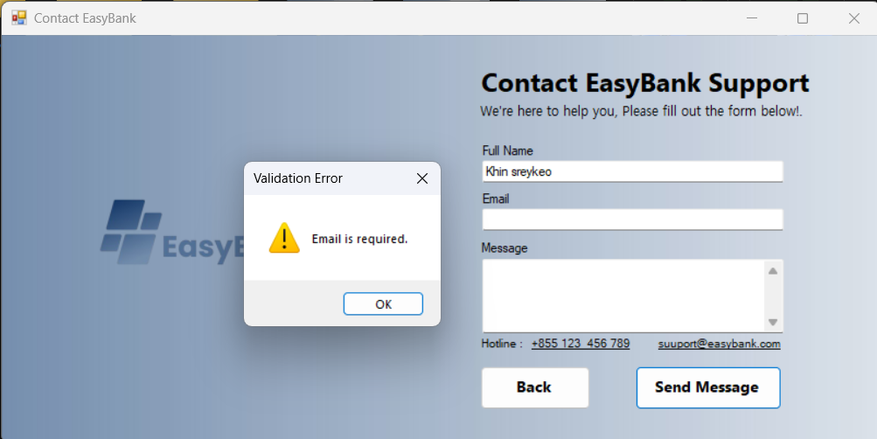
- Missed the required field:

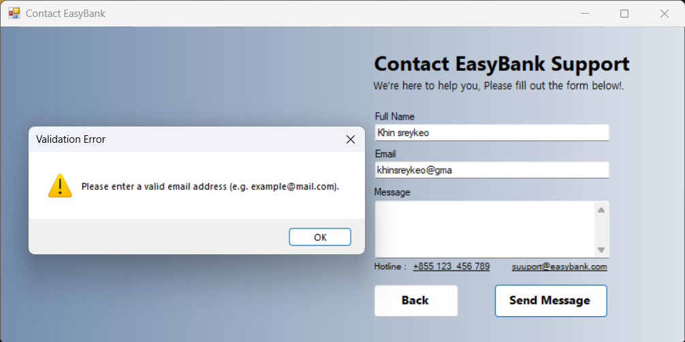
- If user input wrong format of email:

- If they missed the required fields:
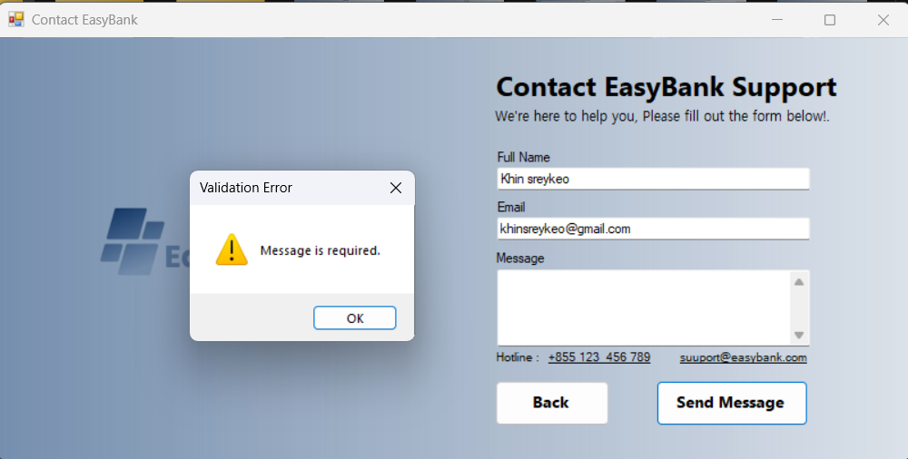

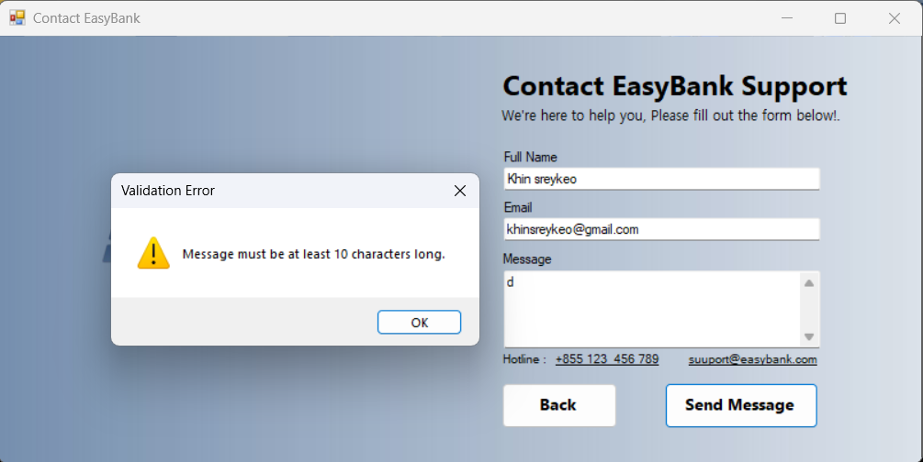
- The invalid data:

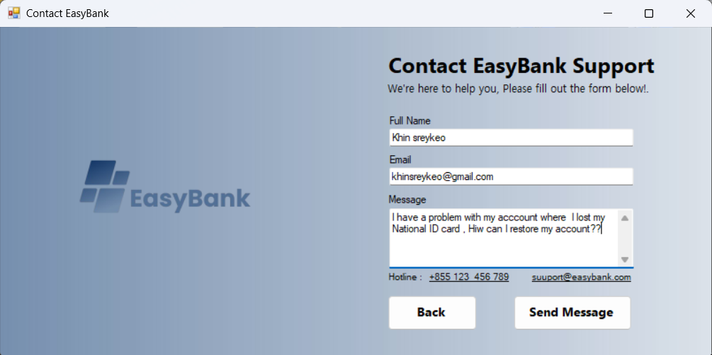
- Raise your concern here, then the system will alert you a message and store in database as below:

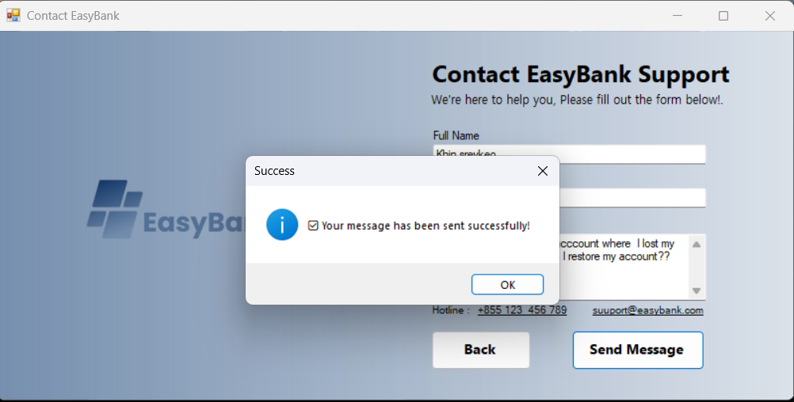

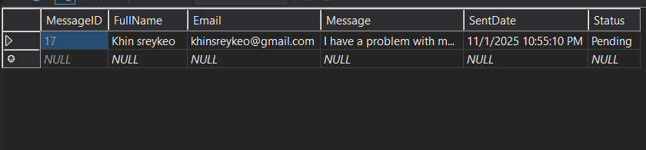

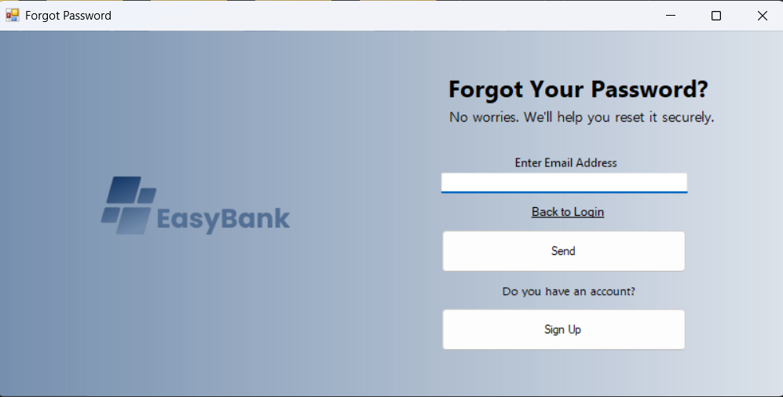
- 5th Form : frmForgotPassword

This form from the frmWelcome, they can reset their password by input the email address, the system will send them OTP to verify.
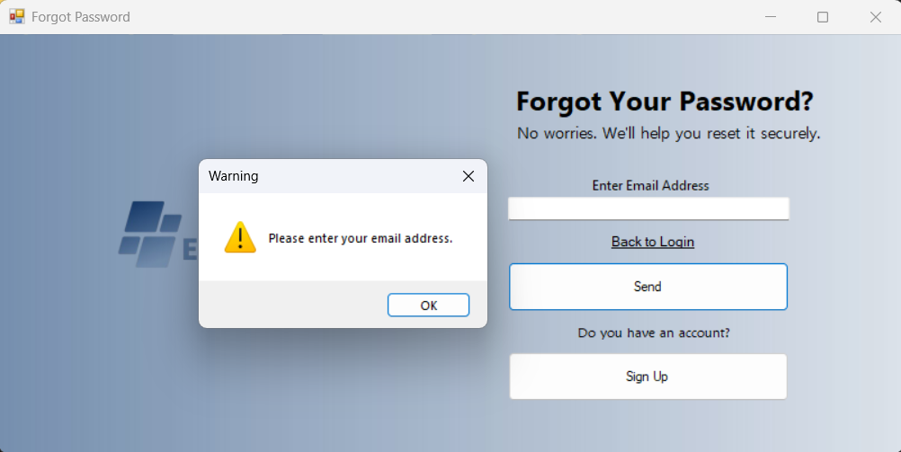
- To reset you must input your email:

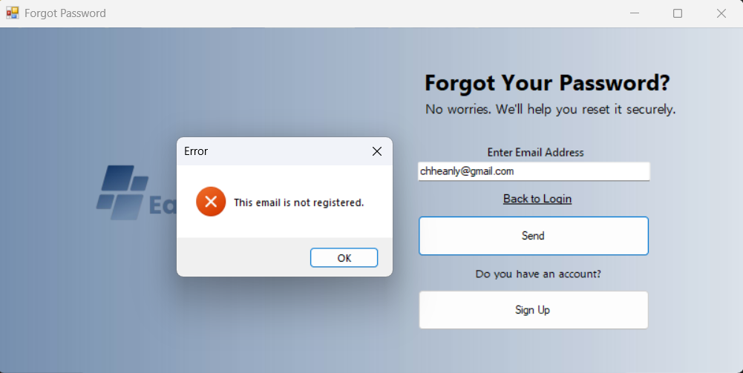
- Make sure their email is valid and existing, if not the system will alert the message as below:

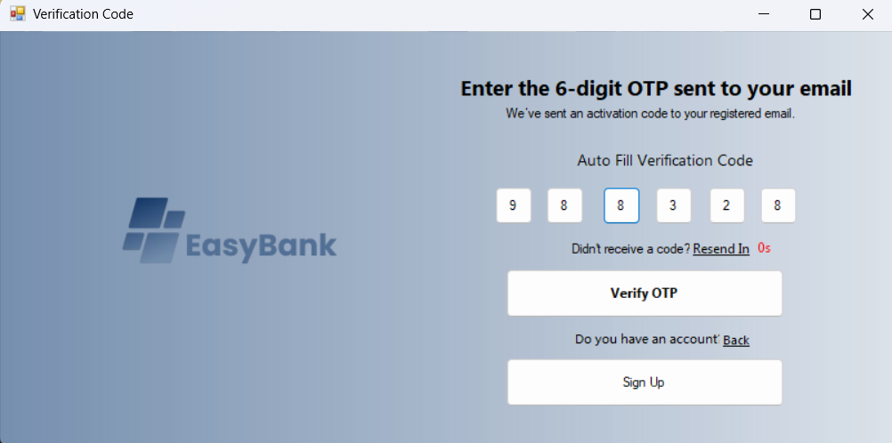
- After validated on email address the user click btnSend, the system will generate the 6 digits of OTP to their email as shown below:

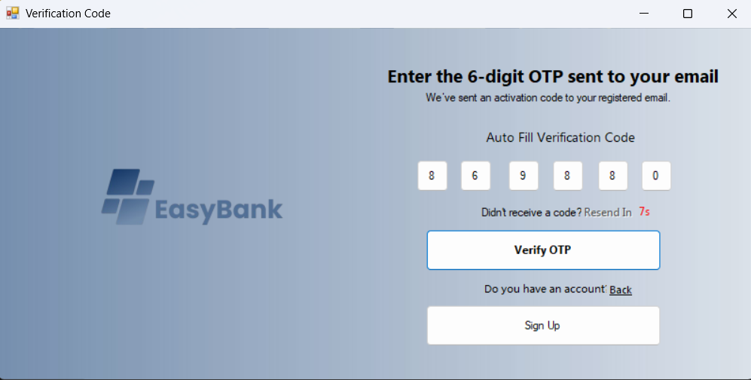
Anyway, if an old OTP is already expired the user can also click the Resend In then the system will send them again.

After that, click the btnVerifyOTP the system will directly open the new form to create a new password.
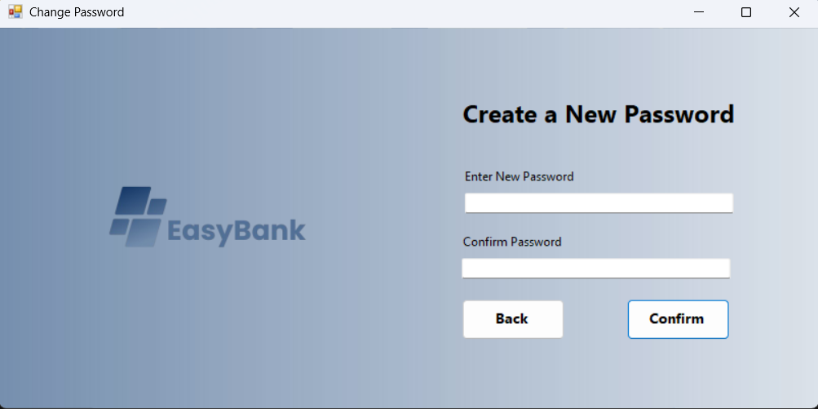
- 6th Form: frmCreateNewPassword
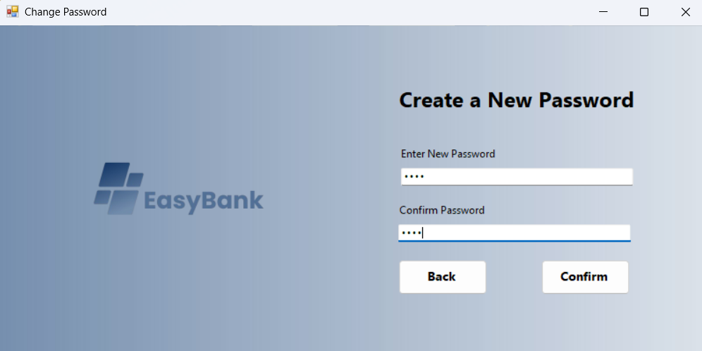
Ensure your password is numeric, then click btnConfirm the system will re-store your password in database:
